

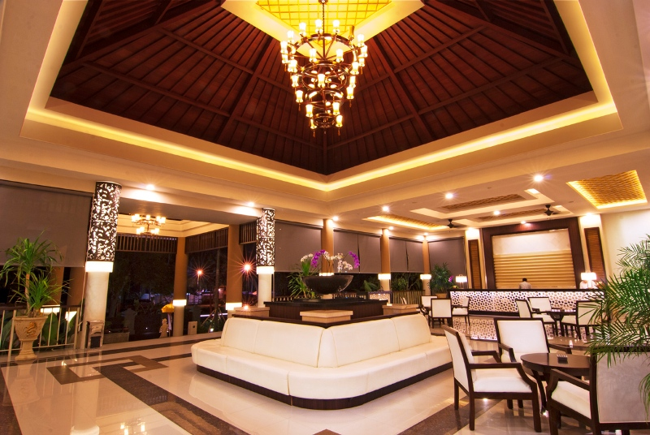
www.balirelaxing.com

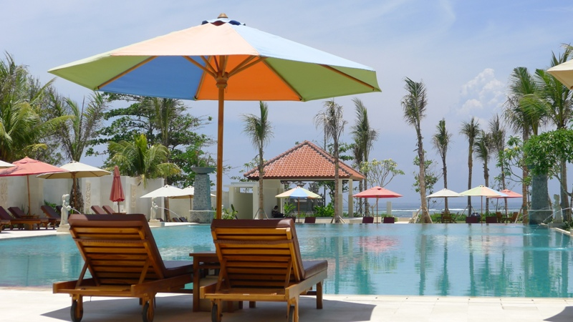 | 每晚只須HKD 500  (只適用2018年入住)
 | 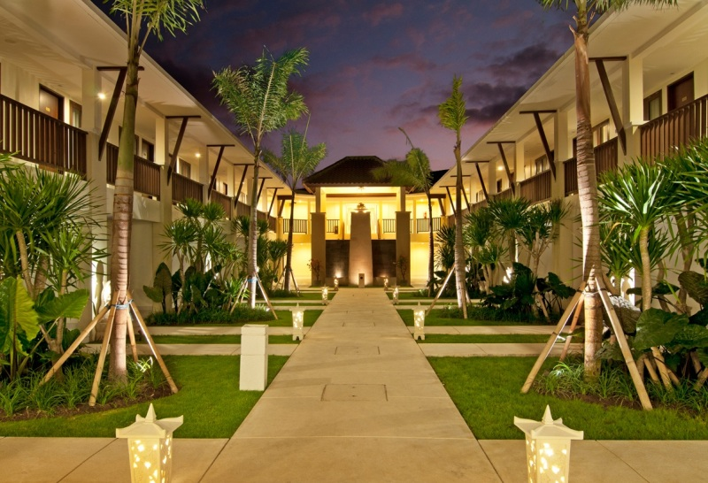
Jl. Pratama No 62, Tanjung Benoa, Nusa Dua, Bali 80361, Indonesia Phone. (0361) 778333 Fax (0361) 778881
Further information & reservation please contact :- Ms. Peggy & Rebecca.
Sales Department: Berry
-------------------------------------------------------------------------
 | Reservation: 2366 5999  Sales :2366 9649 |  | Fax: 2739 5508  Fax: 2724 5185

香港總代理 :
01/03/2018

